Assignment 2

COMP 4107

Group Members: Aidan Crowther

100980915

David N. Zilio  
 100997259

Date: October 28th 2018

# Q1

1. Asdf
2. Investigation results in following responses
3. AA close up of a piece of paper

   Description generated with high confidence
4. Asdf
5. Sigmoid
6. Gradient Descent Optimizer Epochs: 24 Final MSE: 0.019556148  
   Momentum Optimizer Epochs: 11 Final MSE: 0.017951267  
   RMS Optimizer Epochs: 9 Final MSE: 0.010692263
7. A screenshot of a cell phone

   Description generated with very high confidence
8. A screenshot of a cell phone

   Description generated with high confidence
9. Best accuracy after 100 epochs is: 0.0010628295 from RMS Optimizer  
   Gradient Descent Optimizer Epochs: 24 Final MSE: 0.019556148  
   Momentum Optimizer Epochs: 11 Final MSE: 0.017951267  
   RMS Optimizer Epochs: 9 Final MSE: 0.010692263A screenshot of a cell phone

   Description generated with high confidence

1.

2.

3.

4.

# Q2

1. AsdfA picture containing text

   Description generated with high confidenceA screenshot of a cell phone

   Description generated with high confidenceA close up of a map

   Description generated with high confidence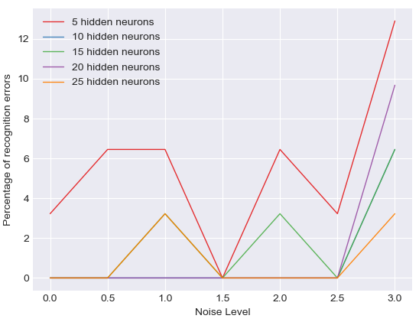
2. AsdfA close up of a map

   Description generated with high confidenceA screenshot of a cell phone

   Description generated with high confidence
3. asdf